Lab 3
Natnael Kebede
Section 1
- Screen capture showing all of the new users and groups created
Groups: Shopfloor, Managers, HumanResources
Users: SFUser01, Manager01, HRUser01
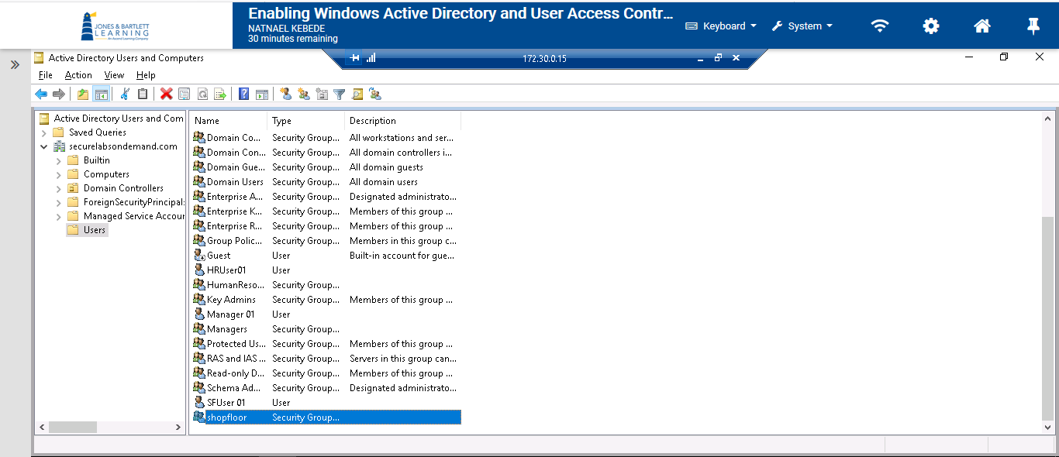
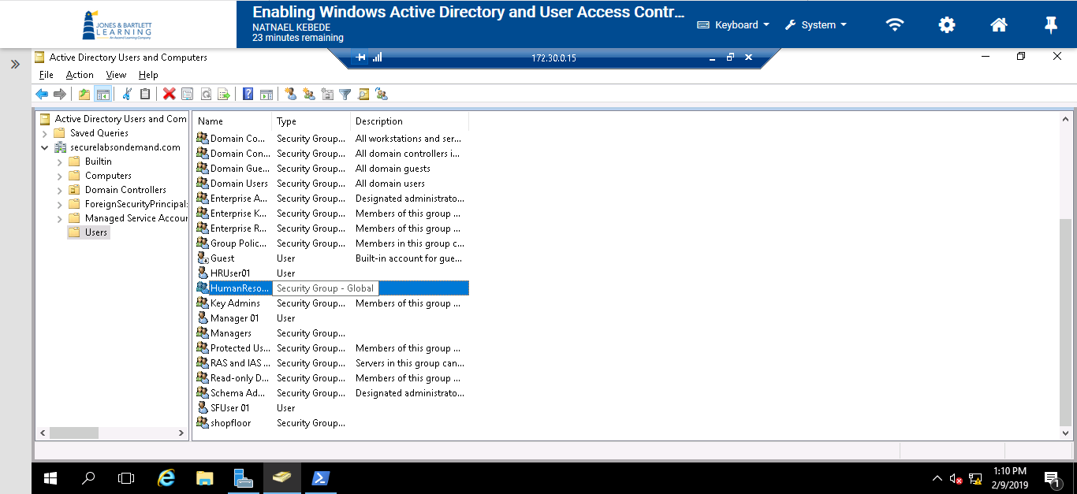

- Screen capture showing the unsucessful access error message to acess HRfiles, the LabFiles folder, and the TargetWindowsDC01 title bar (172.30.0.15).
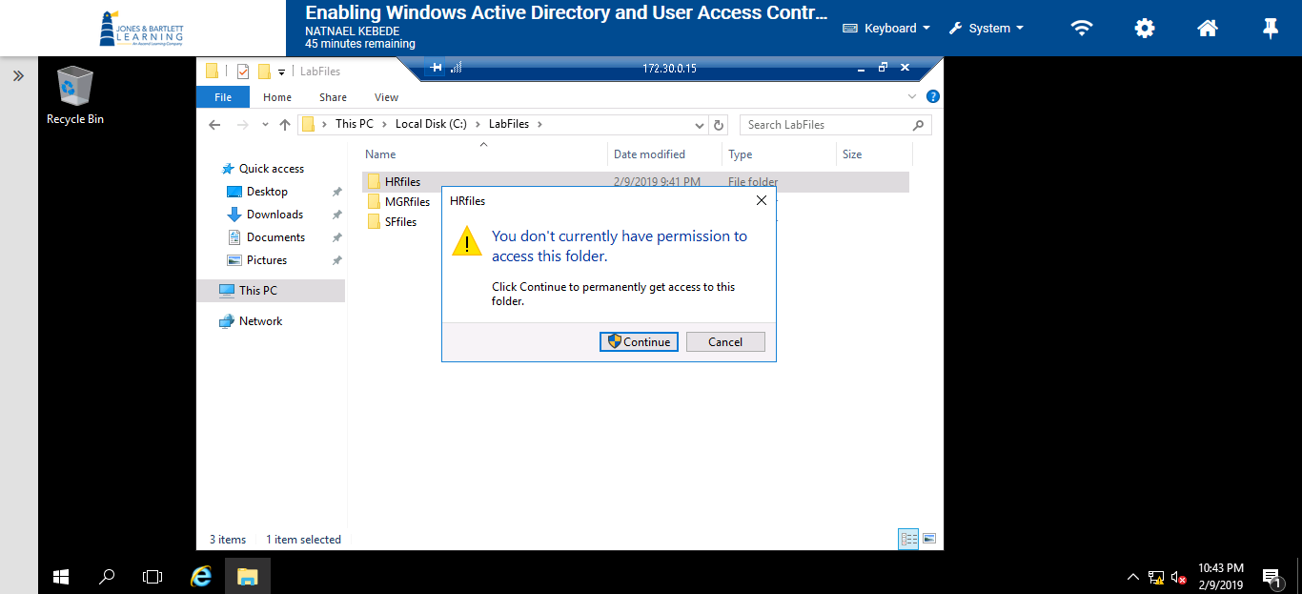
- Screen capture showing the unsucessful access error message to acess MGRfiles, the LabFiles folder, and the TargetWindowsDC01 title bar (172.30.0.15).
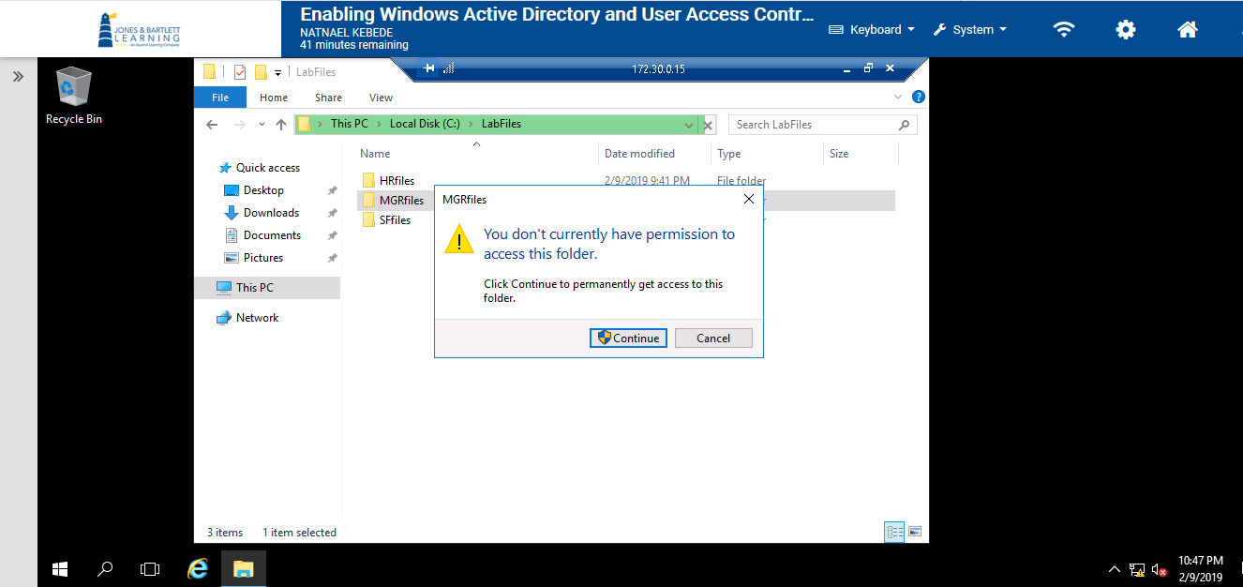

- Screen capture showing the a file sucessfully created in the SFfiles folder with the TargetWindowsDC01 title bar (172.30.0.15).
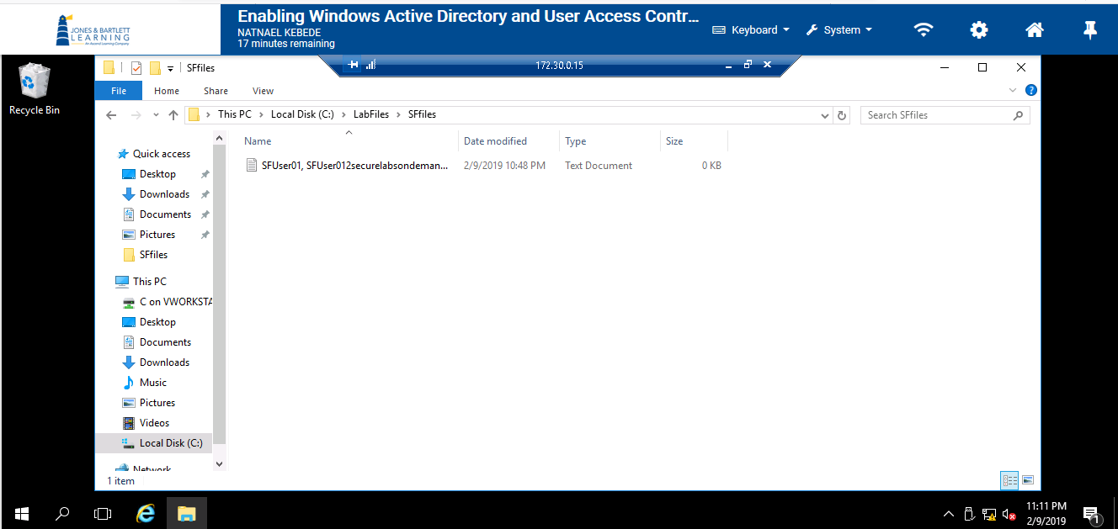
- Screen capture showing the a file sucessfully created in the HRfiles folder with the TargetWindowsDC01 title bar (172.30.0.15).
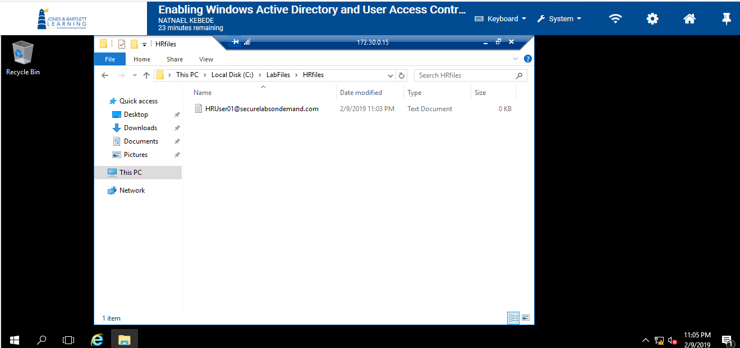

- Screen capture showing the unsucessful access error message to access MGRfiles, the LabFiles folder, and the TargetWindowsDC01 title bar (172.30.0.15).
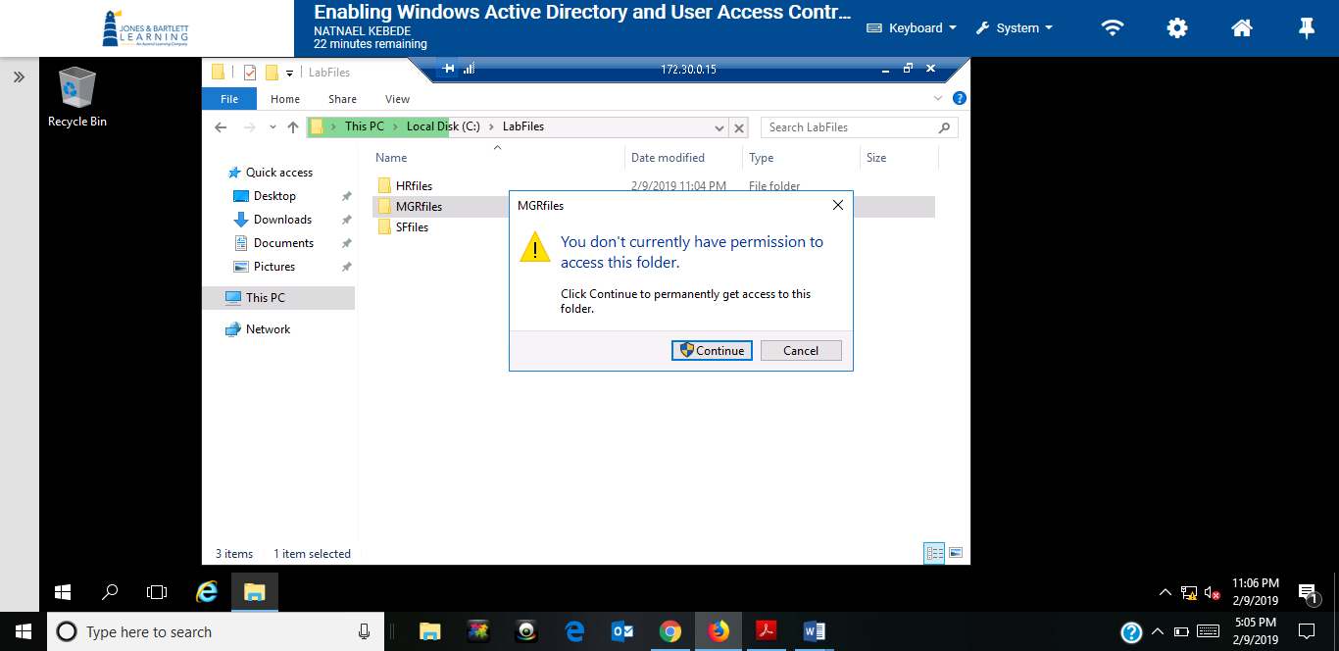
- Screen capture showing the unsucessful access error message to access SFfiles, the LabFiles folder, and the TargetWindowsDC01 title bar (172.30.0.15)
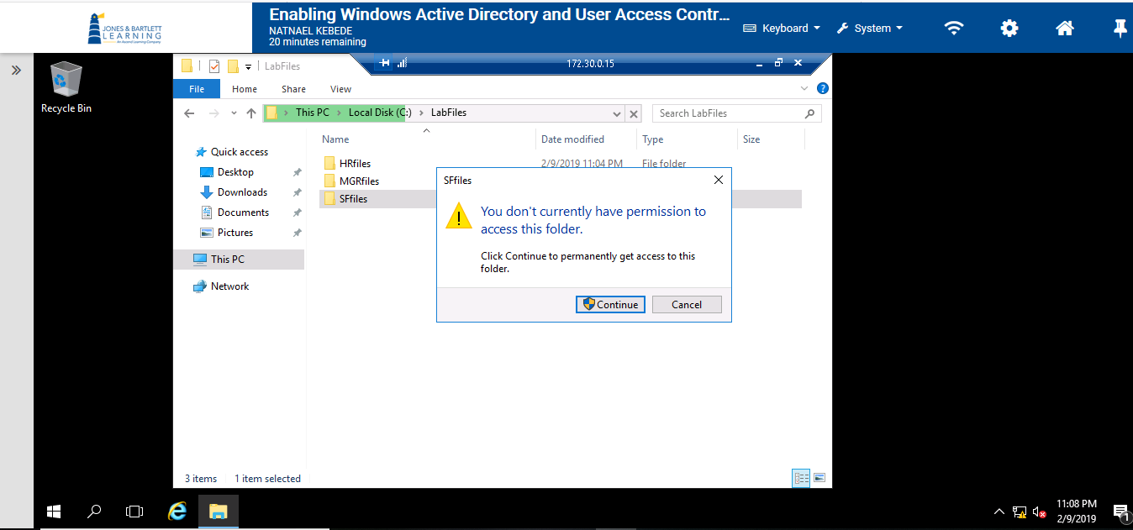

- Screen capture showing the unsucessful access error message to acess HRfiles, the LabFiles folder, and the TargetWindowsDC01 title bar (172.30.0.15).
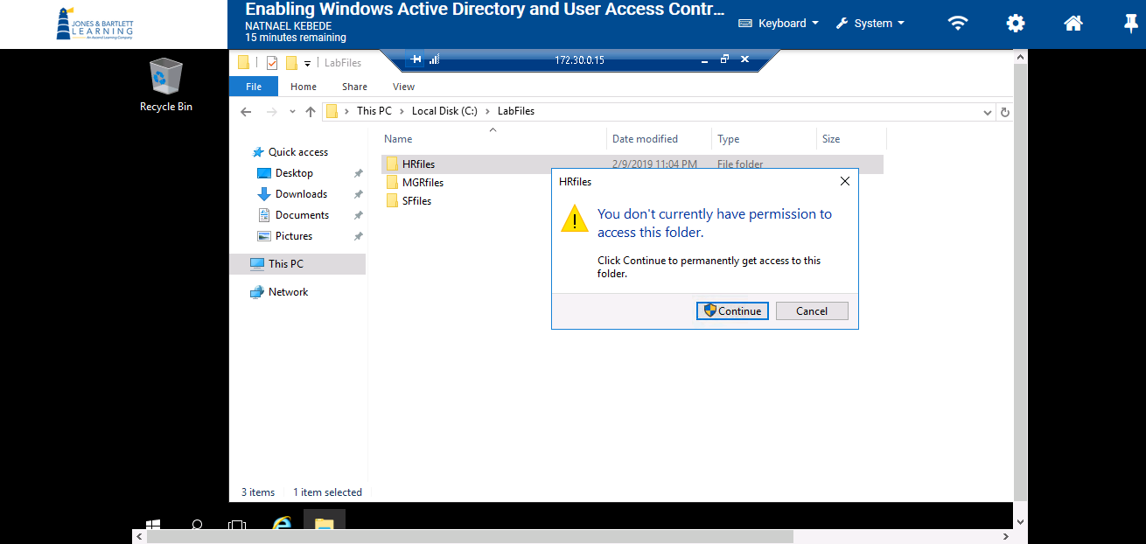
- Screen capture showing the a file sucessfully created in the MGRfiles folder with the TargetWindowsDC01 title bar (172.30.0.15).
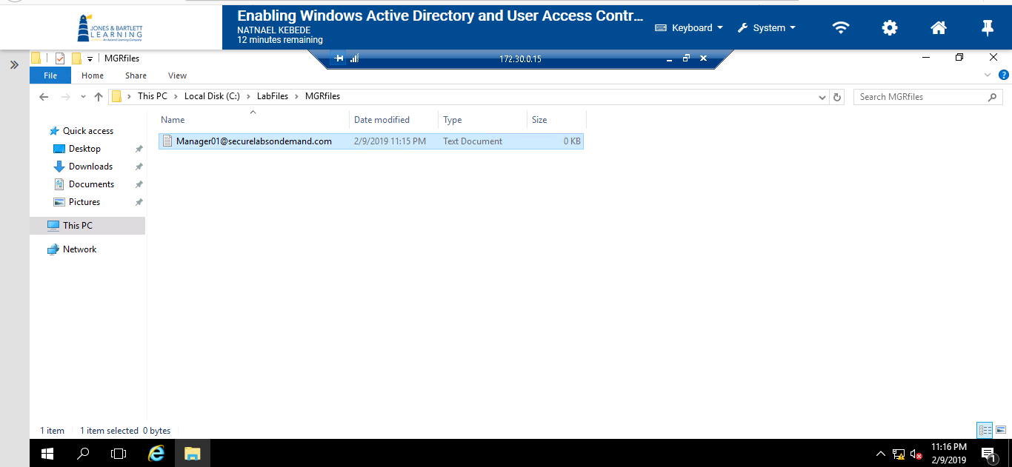

- Screen capture showing the sucessful access to access SFfiles, the LabFiles folder, and the TargetWindowsDC01 title bar (172.30.0.15).
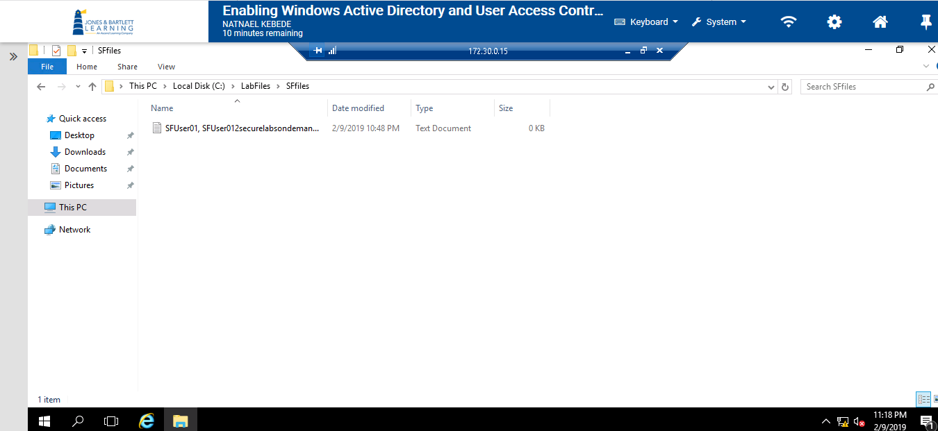

Section 2
- Screen capture showing new users and groups created
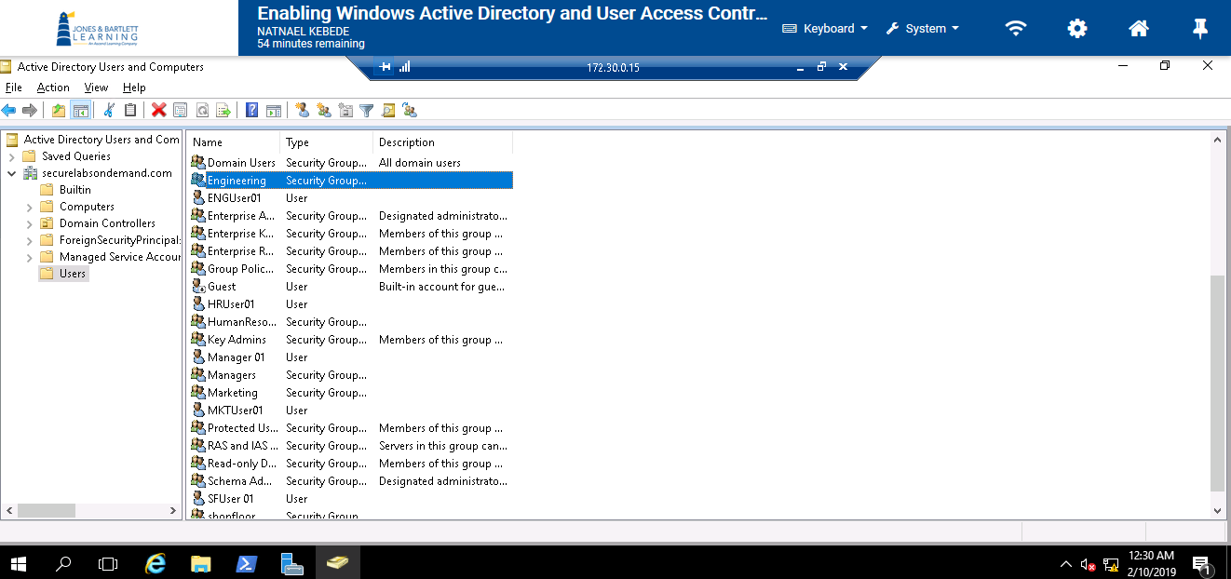

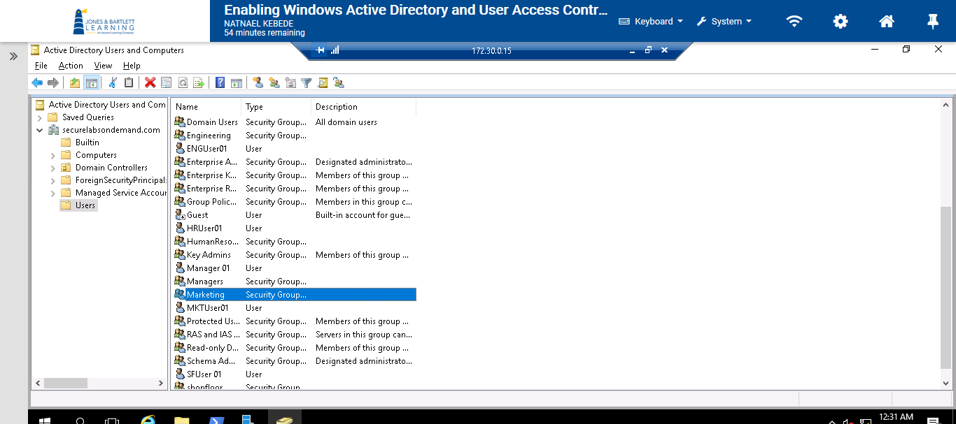
- Screen capture showing the commands used to restrict the ENGfiles and MKTfiles folders
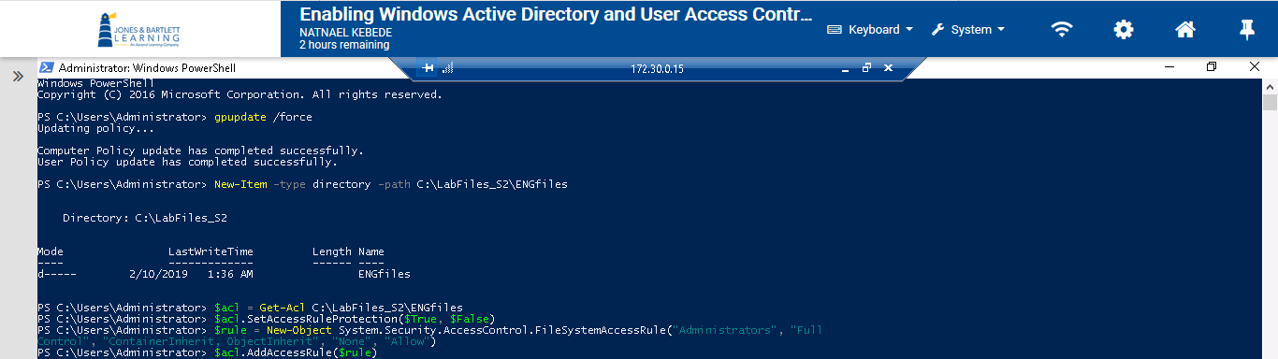
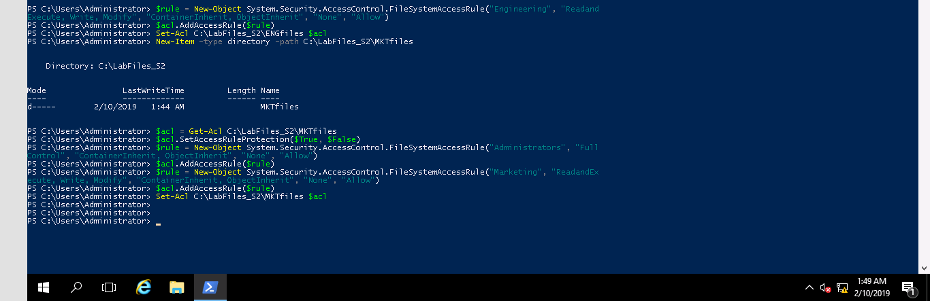

- Screen capture showing the unsucessful access error message to acess MKTfiles, the LabFiles_S2 folder, and the TargetWindowsDC01 title bar (172.30.0.15).
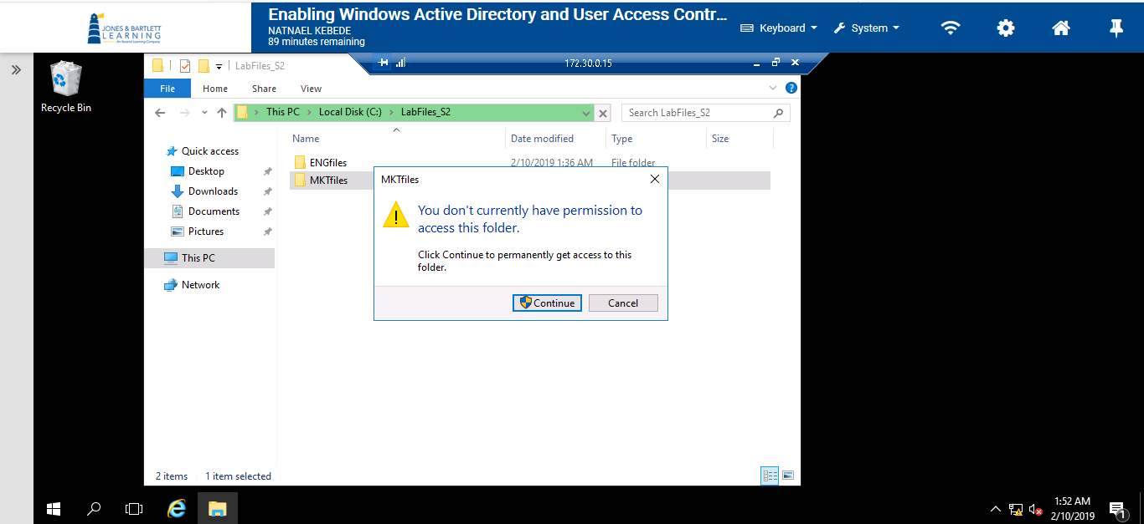
- Screen capture showing the sucessful access to access ENGfiles, the LabFiles_S2 folder, and the TargetWindowsDC01 title bar (172.30.0.15).
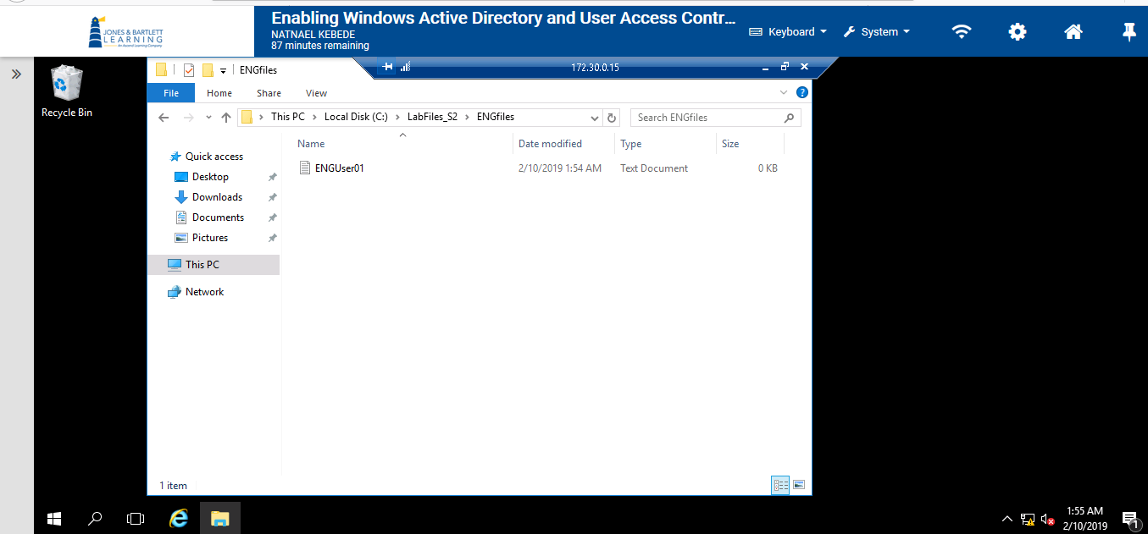

- Screen capture showing the sucessful access to acess MKTfiles, the LabFiles_S2 folder, and the TargetWindowsDC01 title bar (172.30.0.15).
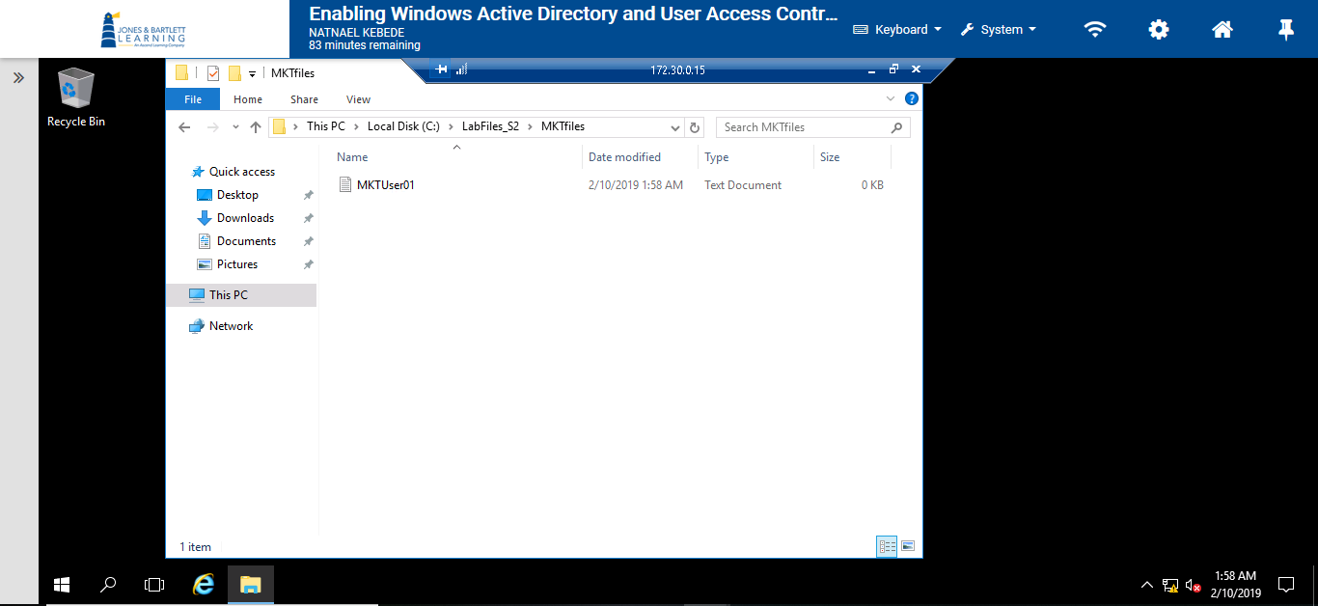
- Screen capture showing the unsucessful access error message to acess ENGfiles, the LabFiles_S2 folder, and the TargetWindowsDC01 title bar (172.30.0.15).
